Contents
Surfacer Wings 2
Undead Wings 5
Duergar Wings 16
Underdark Wings 24
Sorcere Arcanum (Shared Living Faction Questline) 30
The Shadow Lair (Living Questline) 35

Surfacer Wings
Surfacers (that start in Benzor) will need to start the quest chain by talking to some guards near a body by the fountain. That starts "A Horrific Crime in Benzor 1 & 2"
Take a boat to Mulrok -> boat to Fort Fakault. Green question mark is your target.
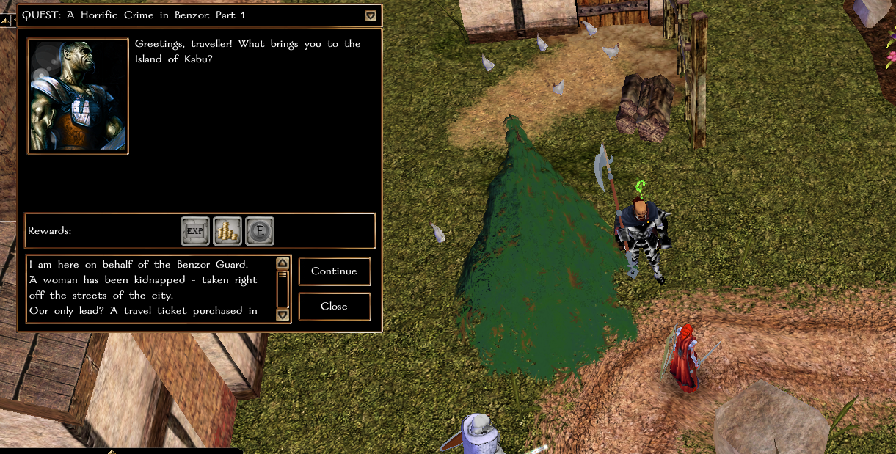

Fight or sneak your way through Ruumania Mausoleum to the boss area (note the fire line past the doorway)
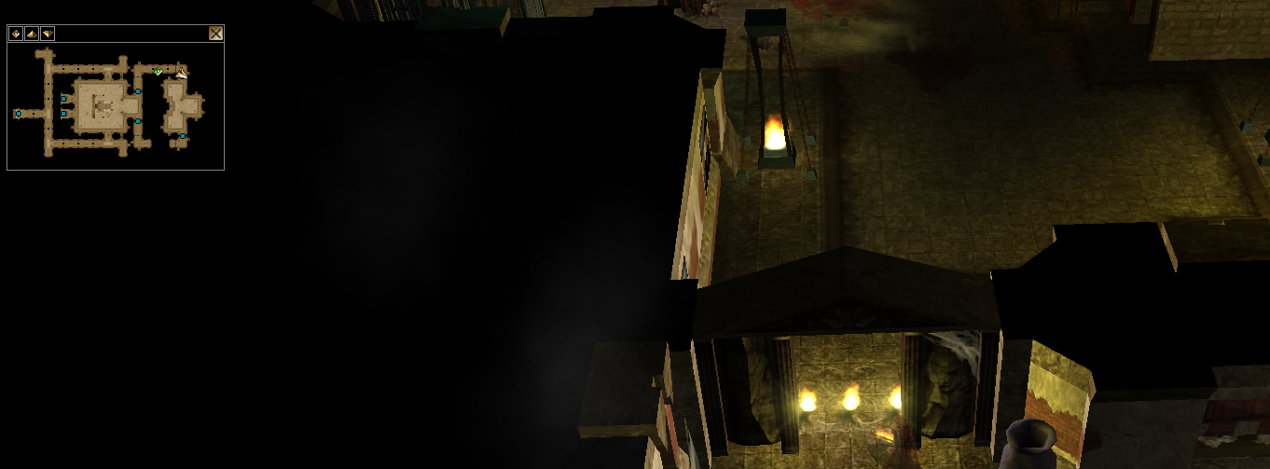

Read the Lich’s journal to start "Necromancy of Unknown Origin" (I usually burn my port to default location here to save the walk back)
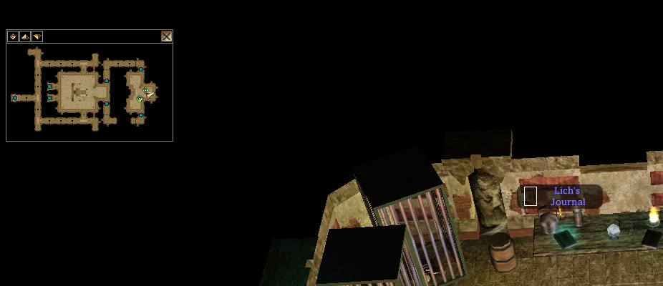

Talk to Galdor the Gold dragon in Benzor
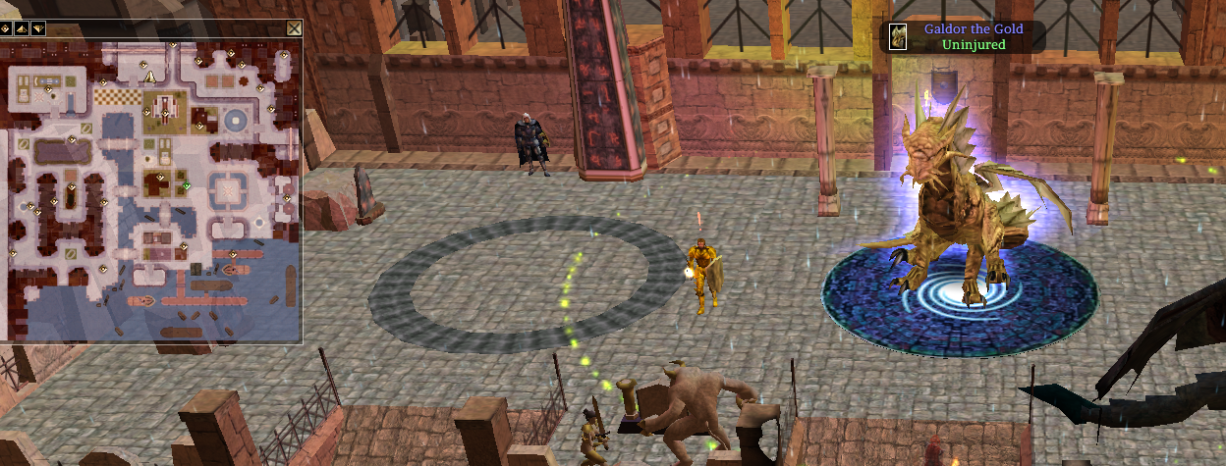

Take a boat to Brosna, go to Werdna’s Enchantments and speak to Werdna
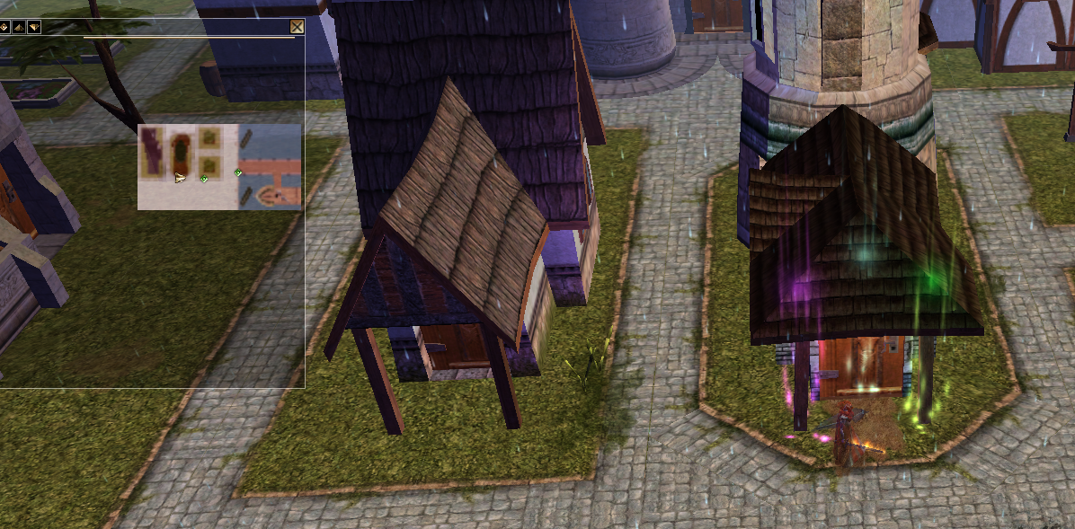

Take a boat back to Benzor. Speak to Galdor to complete basic wings, then again to start Necromancy of Unknown Origin Part 3
Next you’ll need to head to Chaulssin to get a Cleansed Token of Possession. See the section Sorcere Arcanum (Shared Living Faction Questline) for instructions. Once you have that, head back to Galdor to start The Shadow Lair (relevant section at the end)

Return to Galdor to start Defeat Blackavar (from this point on you can join a LIVING wings party) and you need to keep the Energized Token of Possession on you!

Undead Wings
Start with Graves Management 1*. From Nocturnae, go south to Dead Fields. The quest giver Grave Keeper Willy is near the transition. A few kobold spawns are marked in red here.
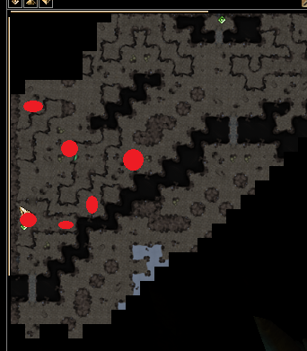
Return to Grave Keeper Willy for Graves management part 2: zombie spawns in red; transition to crypts with more zombies in yellow. There’s another transition with lots of zombies next to the 2nd from top NW red dot
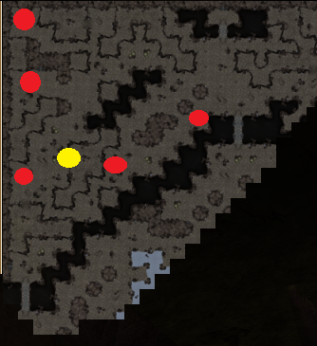
Graves management part 3: corpse eaters are in the same graveyards
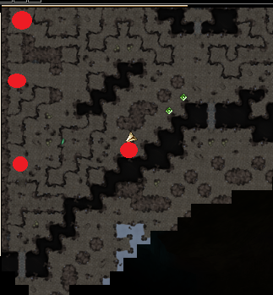

Continue on to Corpse stealing 1. Quest giver is again near the transition from Dead Fields to Nocturnae. Your target is NW part of Dead Fields
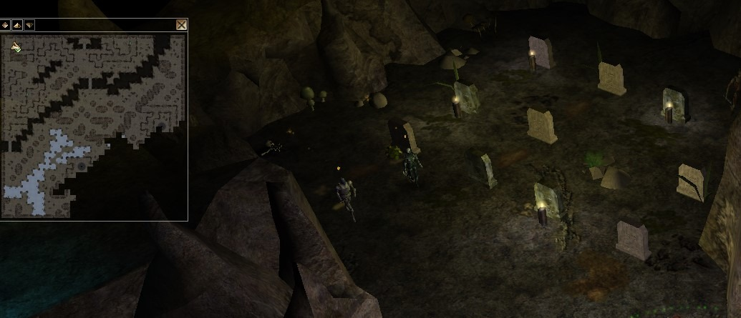
Corpse stealing 2 I recommend you put on an Amulet of Fire Resistance if underleveled. There's a ballista trap, DC17 that can hit you for 72 fire damage.
From Nocturnae, go south to Undercave
Take the small boat to Gloomy Dark

Then take the boat to Underdark South. Head to the NE part of map. Get papers.
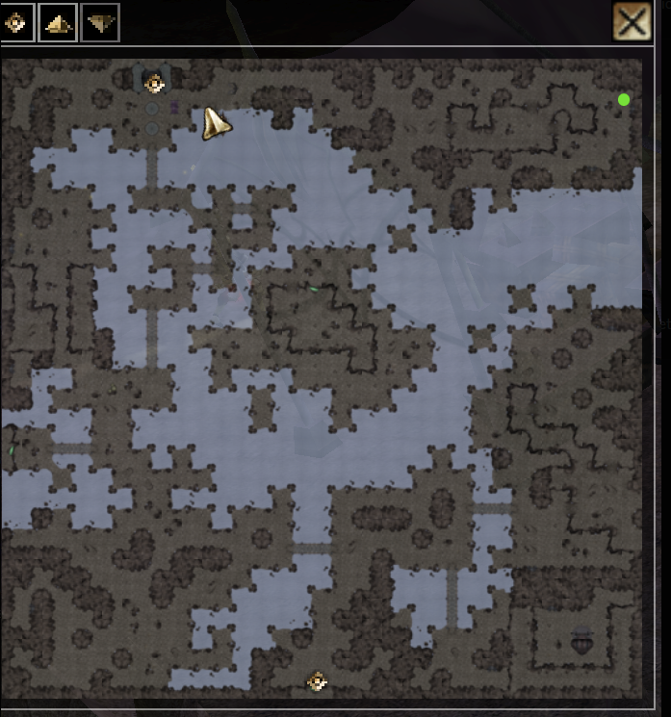

Corpse stealing 3 Talk to the big dragon Ebondeath Lord of Death in the NE part of Nocturnae
**Awaken Heroes 1** (bring Alohohora or rogue henchman) don't need to unlock going this path (see below for alternate path):
Nocturnae -> south to Undercave
-> small boat to Gloomy Dark
-> south to Deep Caverns
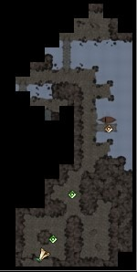

NOTE: this area is generally safe, but the spawns scale with level. If a high level ran through earlier and didn't clear, you will want to stay invis.
Cross the bridge, pass through the caves (you are still in Underdark Deep Caverns; lots of quests here to pick up too)
Exit the cave to NW, enter new cave here (don't touch the mirror!)

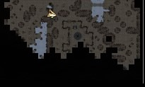

Exit, go up stairs here, which takes you to Tomb of Forgotten Heroes
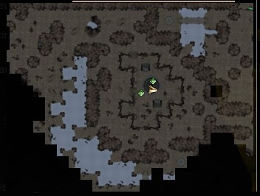

*Alternate route: From Benzor go East through River Valley, East March, Trommel, and to Common Wood. In Common Wood go South to the temple ruins in the lower corner. You may need to unlock the door (Rogue Hench or Alohohora needed for this). This route is more running but less convoluted.

Grab the dormant skeletal remains. Killing the Cursed Paladin is optional.
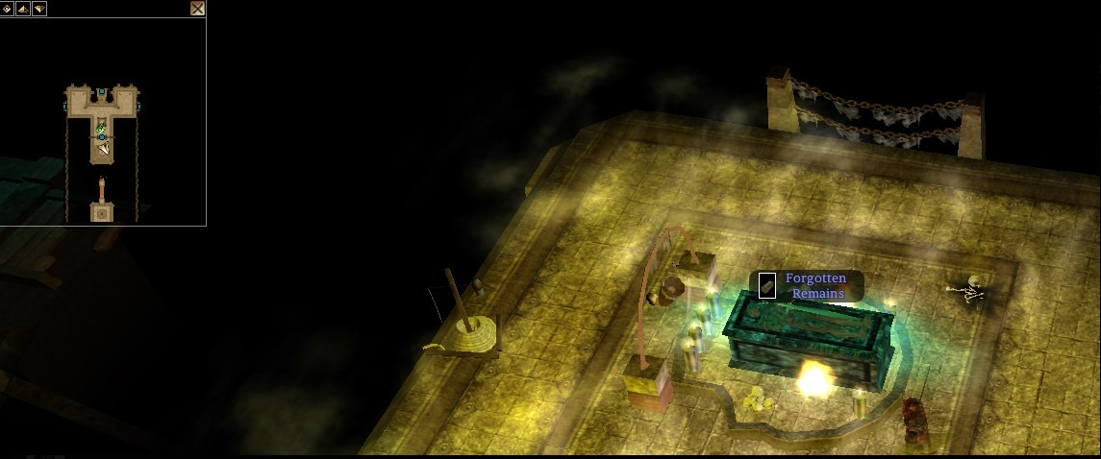
Return to Ebondeath to get initial wings. Speak to it again to start Awaken Our Hero: Part 2
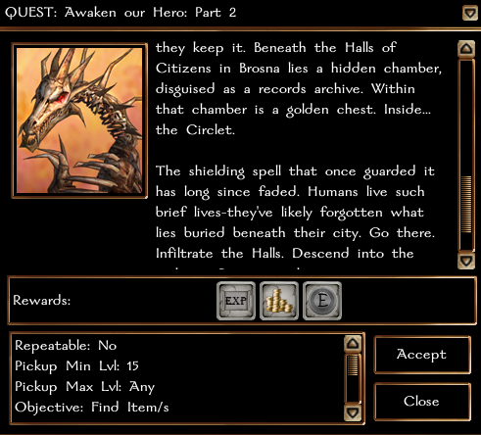
Port to Mulrok -> Boat to Benzor -> buy ticket from Cappy Deek -> Boat to Brosna

Enter Hall of Citizens
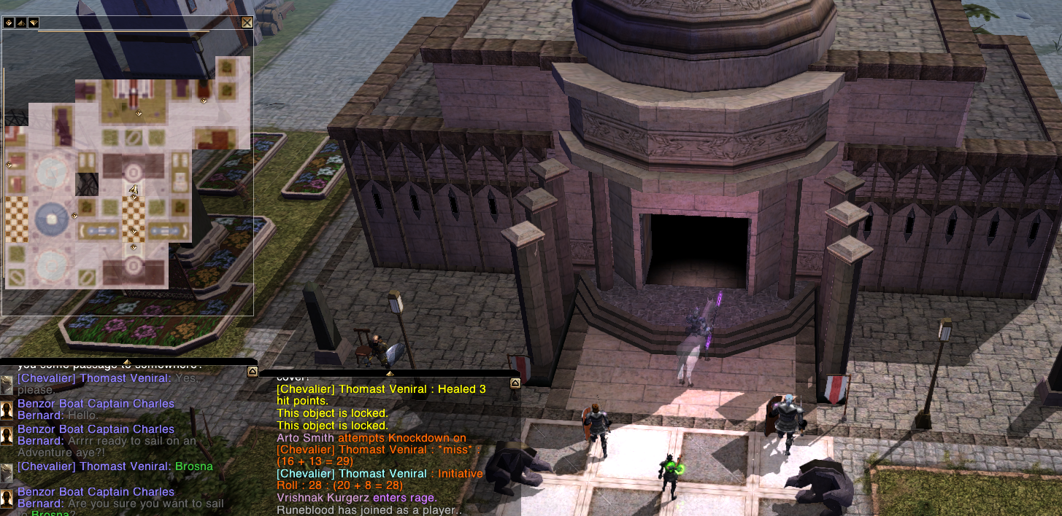

Go downstairs SW to enter dungeon
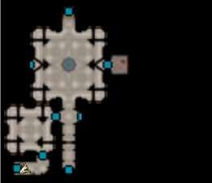
(Can re-mount inside dungeon if needed)
Kill your way through Records Keeper Leopold II
Loot the Gold Bound Chest for Silver Circlet quest item
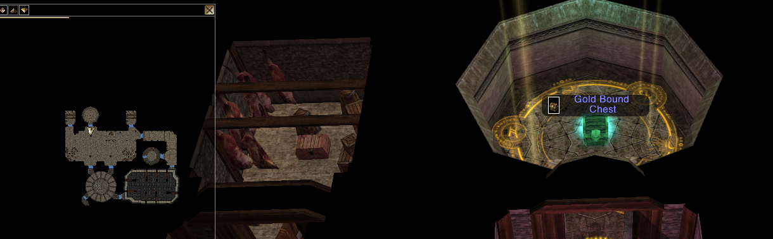

Don’t forget the silver chest (Celestial Silver Key)
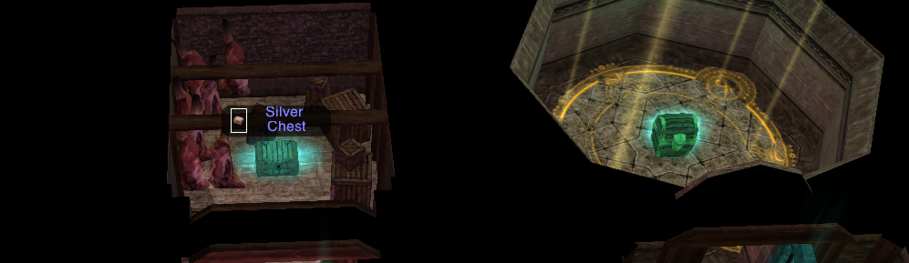

Return to Ebondeath, start Awaken our Hero Part 3
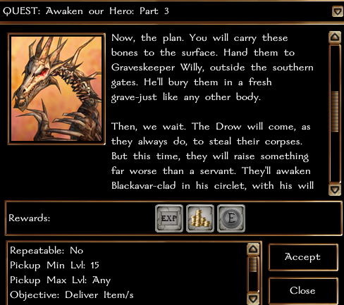
Go south to Dead Fields, talk to Grave Keeper Willy

Return to Ebondeath to start Protect Blackavar (from this point on you can join an UNDEAD wings party)

Back to Nocturnae -> South to Undercaves, talk to Bright Eye Ship Master -> boat to Misty island
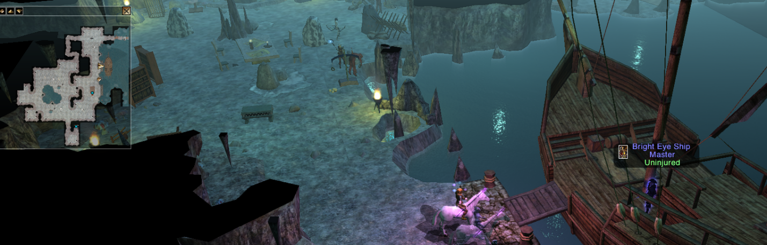

Talk to DARK CAPTAIN to start The Tower of Inodrio
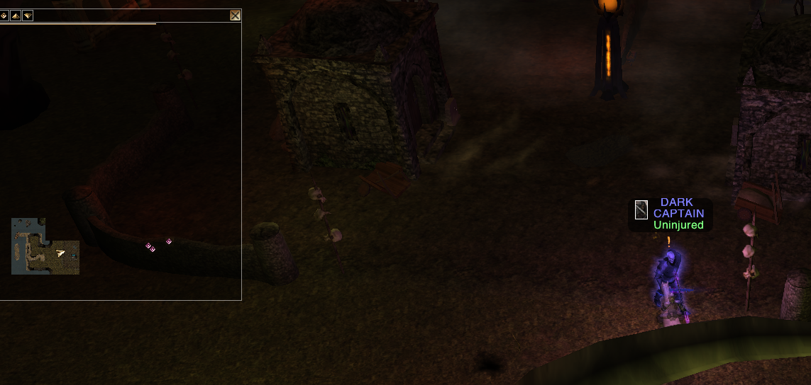

Misty island -> cave here
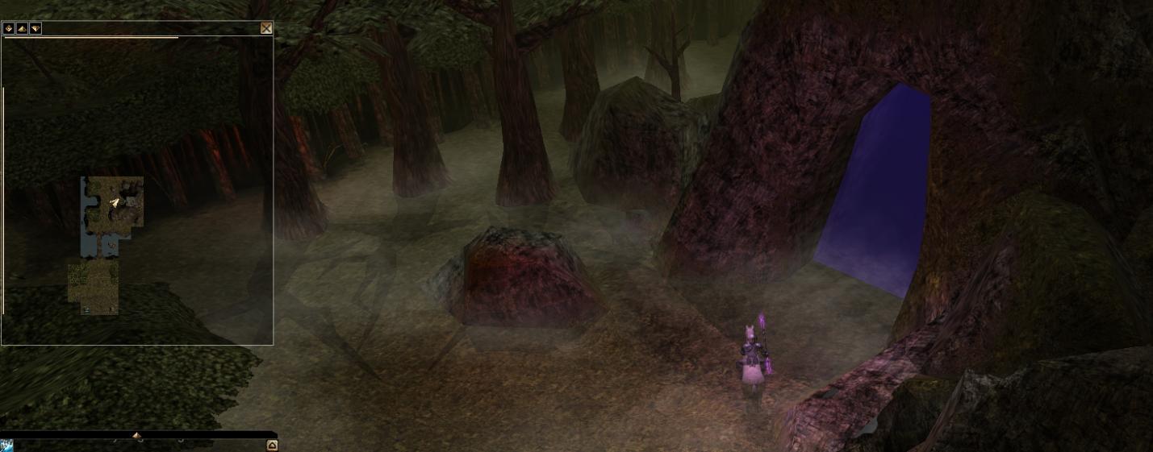
Hit the Gong to summon Riddler. Speak to him to start Entry to the Tower of Inodrio
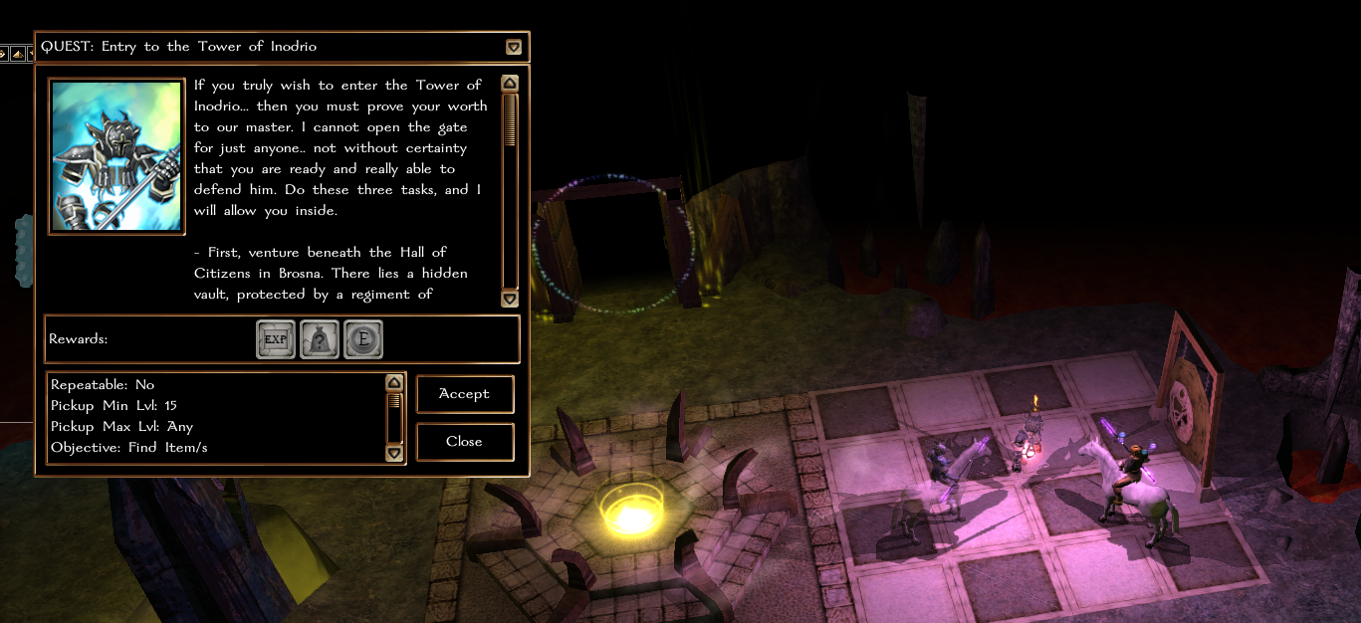

Duergar Wings
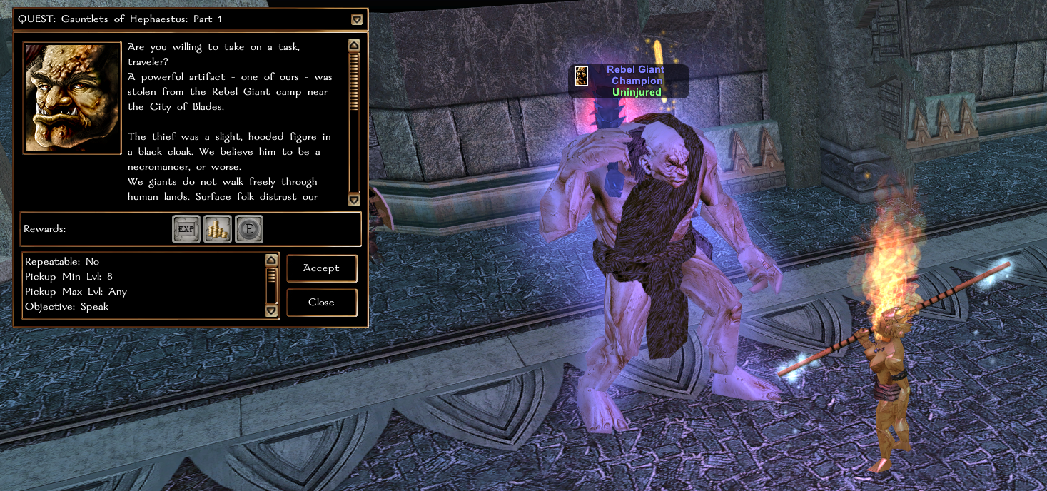
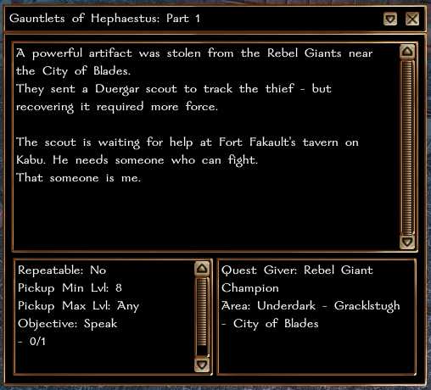
Next take the portal to Mulrok, then buy a ticket at the boat dock to Kabu.
Head into the inn (it’s not marked but has horses out front.)
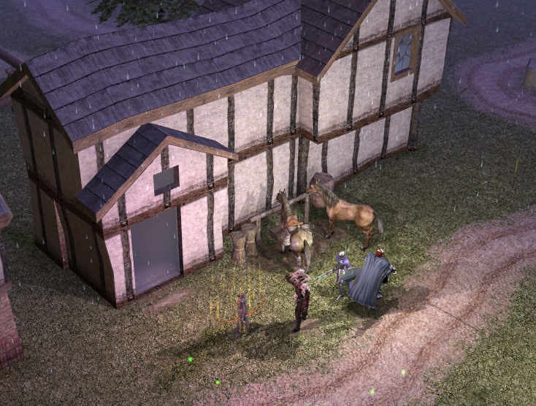

Turn in Part 1 and take Part 2 where you need to head North from the Inn to the Crypts.
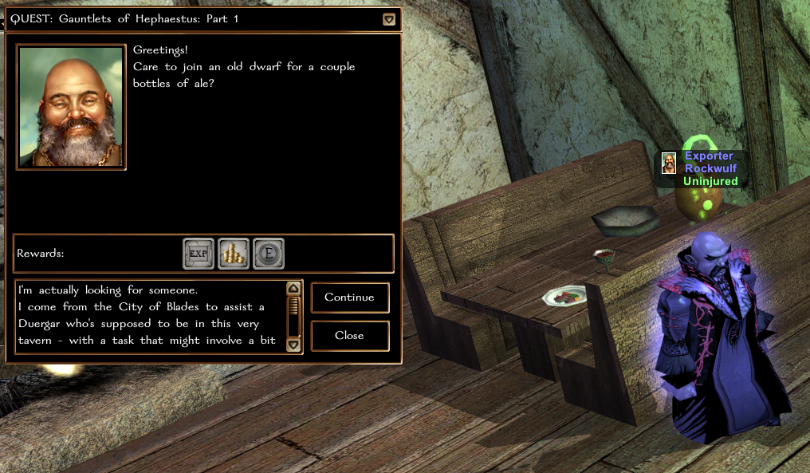
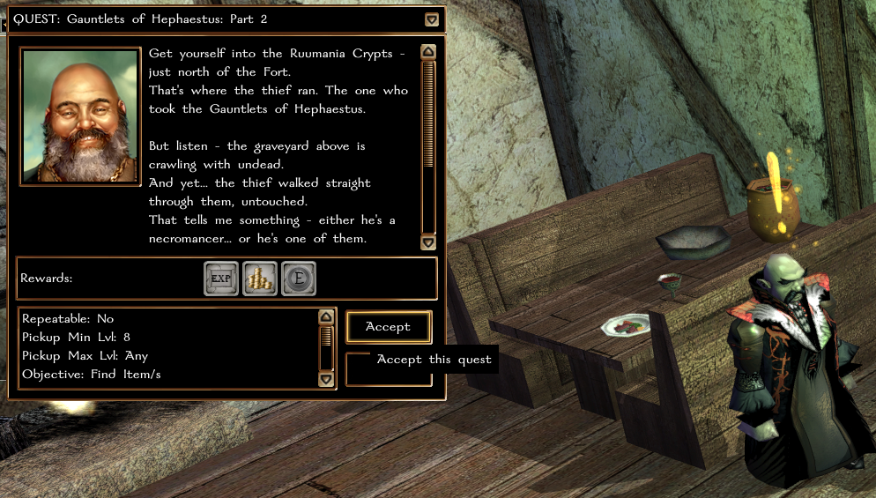

Go into the Crypts and kill the necromancer. Then on the table behind him, get the quest for Part 3 from the Book of Fire Spells. (Unlike Drow which want the Orb, but same idea.)

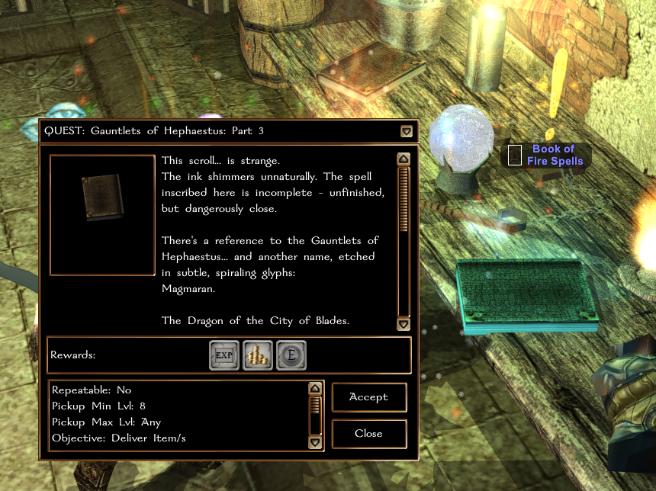
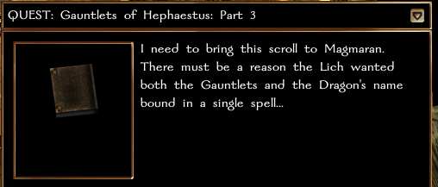
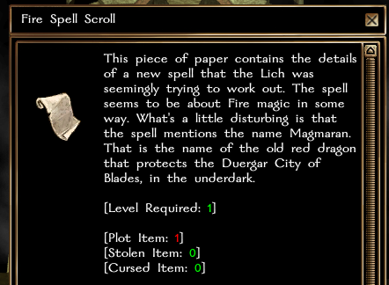
Do not lose this scroll of you’ll be in trouble. Take it back to the Dragon Magmaran in the Duergar City of Blades, Gracklestaugh (back where you started.) First however, go turn in Part 2 back in the Inn since you’re already here!
(Tip: You can use Port to my Default Location from the player menu.)
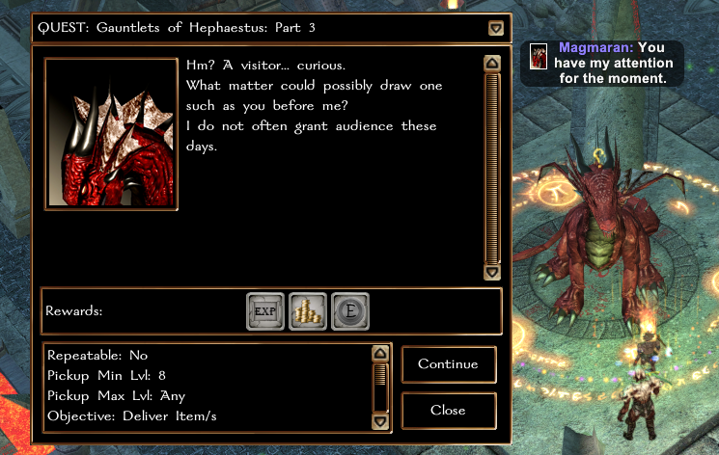
Get the next quest from the Dragon, Magma Protection Part 1.
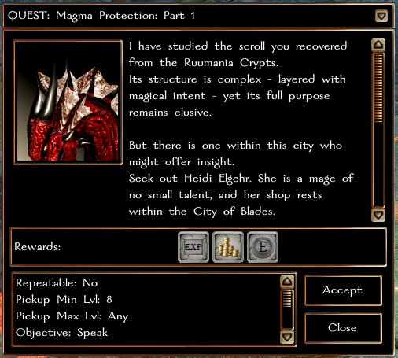
Heidi is in the Market District, North West side of the City. Talk to her and report back to the Dragon.
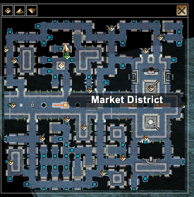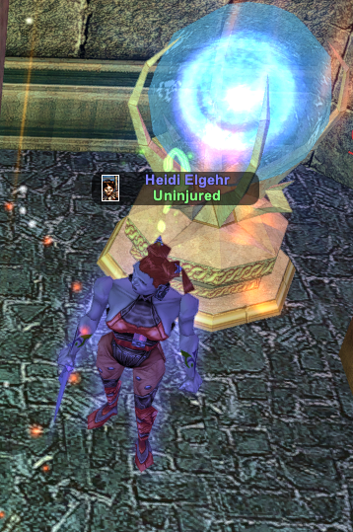
Turning this quest in unlocks the Basic Wings and Henchman can now reach Level 20.
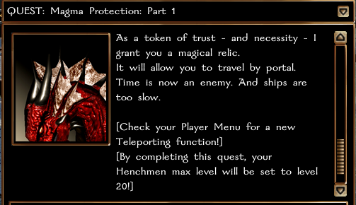

The next phase requires minimum of Level 15 to complete.

Get Magma Protection Part 2 from the Dragon, then head to Chaulssin. The easiest way is to take a boat to either the North or (preferred) South side of Underdark Central, then head south until you get to a boat into Chaulssin. Then it follows the same path as Underdark or Surfacers – Get the Cleansed Token of Possession from the Lloth Priestess. (See Sorcere Arcanum Section)
Return to Magmaran to start Defeat Blackavar (from this point on you can join a LIVING wings party) and you need to keep the Energized Token of Possession on you!

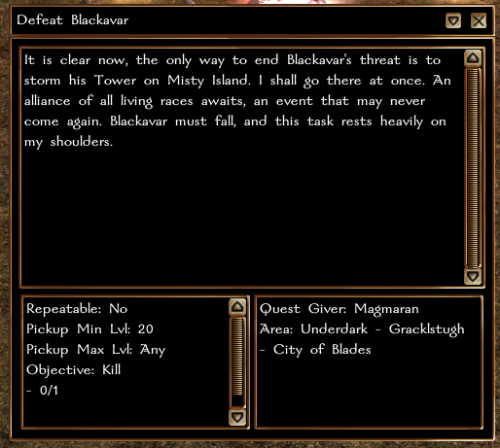

Underdark Wings
Applicable to all DROW and HUMANOIDS factions. (Drow, Driders, Illithids, Minotaurs, Trolls, Demons, etc)
Starting in Underdark Central, speak with Nurvureem Servant beside the Dragon. Take the quest Minotaur Violence: Part 1. Requires Level 8.
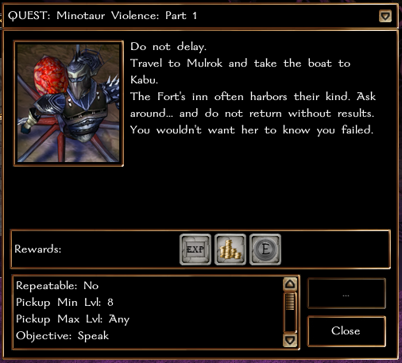
Take the nearby Portal to Loknar, then another portal to Mulrok.
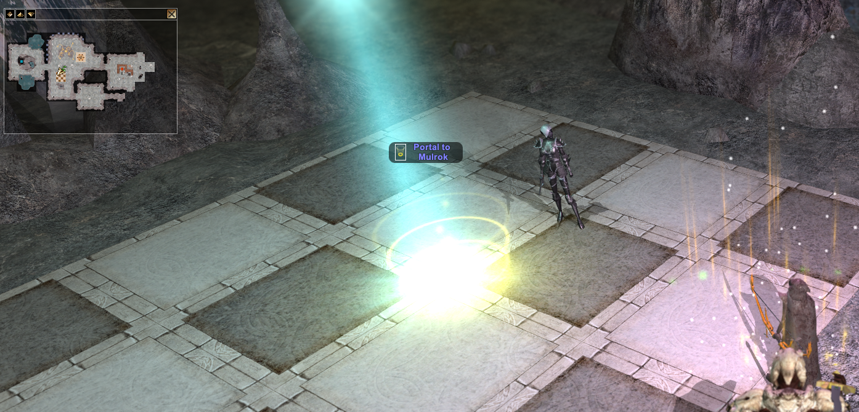

Buy a boat ticket to Fakualt from Alia Wettias beside the boat (that can also be used to sail to Benzor) and head to Kabu - Fort Fakault.
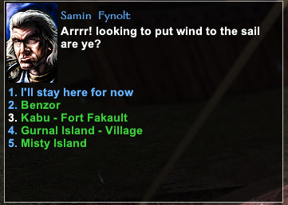
Head into the unmarked building (it’s an Inn) with the horses out front, then turn in Minotaur Violance Part 1 quest to the Merchant Whitehorn (Minotaur) who should have a green ? over his head. Get part 2.
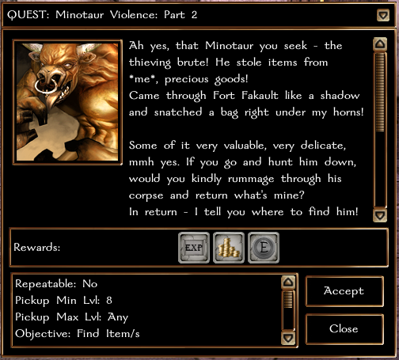

Head into the graveyard just to the North, where you have to fight an undead Minotaur with a Fear Aura (DC 18) so bring clarity potions. Killing the Minotaur gives you a Bag of Stolen Goods to take back to the Merchant Whitehorn in the Inn.
The next task is Part 3 back in the graveyard into the Crypts.
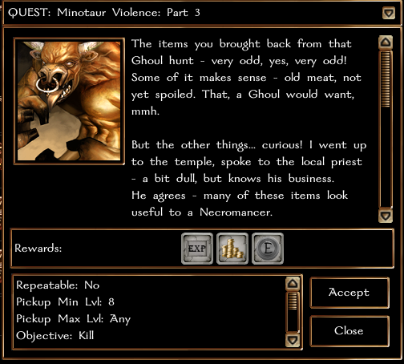

Inside the crypt in the far East side you fight an Awakened Frost Lich. Defeating that allows you to turn in Minotaur Violence Part 3, which also allows you to get the quest from the Orb of Domination on the shelf behind the Lich. That puts an Orb of Domination in your inventory that you take back to the Dragon in Underdark Central. Do not lose this orb! If you drop it somehow, it may make it impossible to get wings on that character!
Head back to drop off Minotaur Part 3 before leaving the area. (Not truly necessary, but you’re already here.)
Make your way back to Underdark Central (you might be able to use your Port to Default Location from your Player Wand) and return the Orb to the Dragon. This unlocks Wings for your character.
Next, talk to the Dragon again at Level 15 to get the next part, which sends you down to Chaulssin. See section: Sorcere Arcanum (Shared Living Faction Questline)

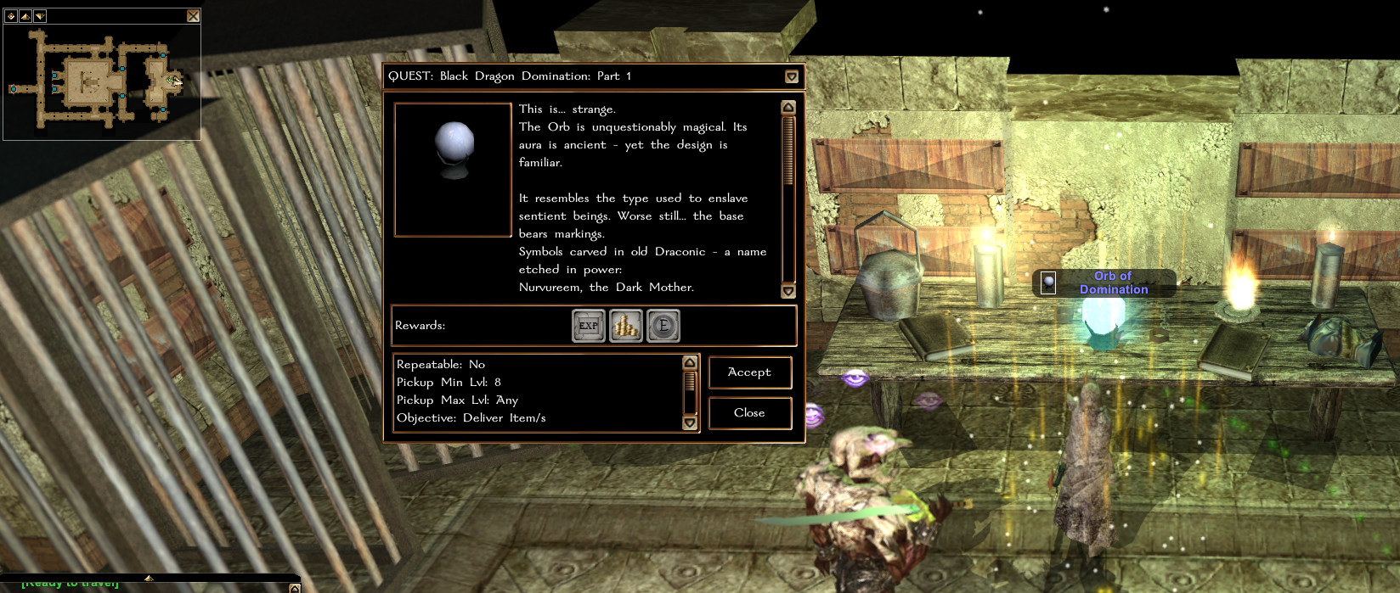

Return to the Drow Dragon to start Defeat Blackavar (from this point on you can join a LIVING wings party) and you need to keep the Energized Token of Possession on you!

Sorcere Arcanum (Shared Living Faction Questline)
Boat to Brosna -> west 3 maps to Sholo plains -> Underdark - Gloomy Dark
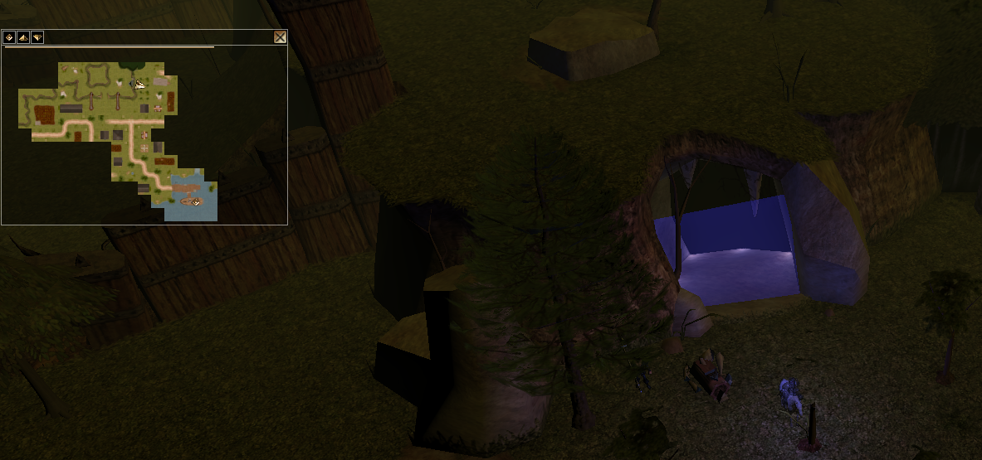

Boat to Underdark - South
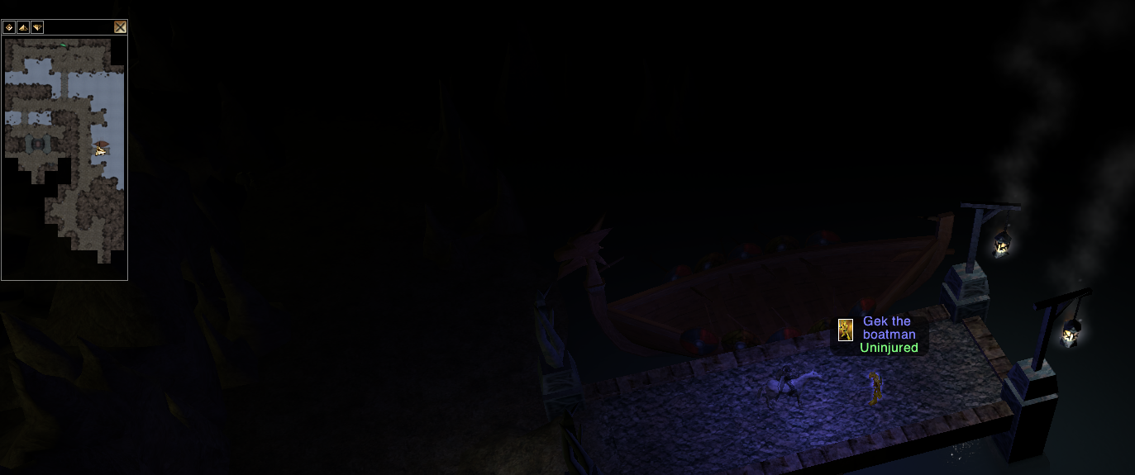
South to Chaulssin
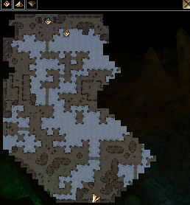
Enter Sorcere Arcanum
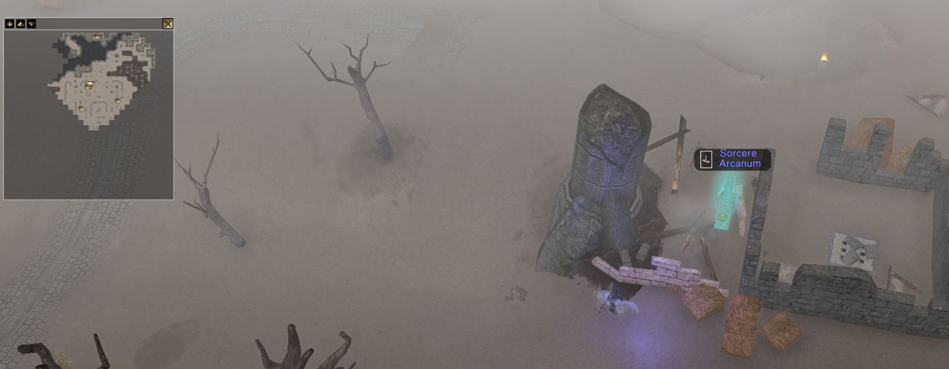

Talk to Sorcere Apprentice Milv’yen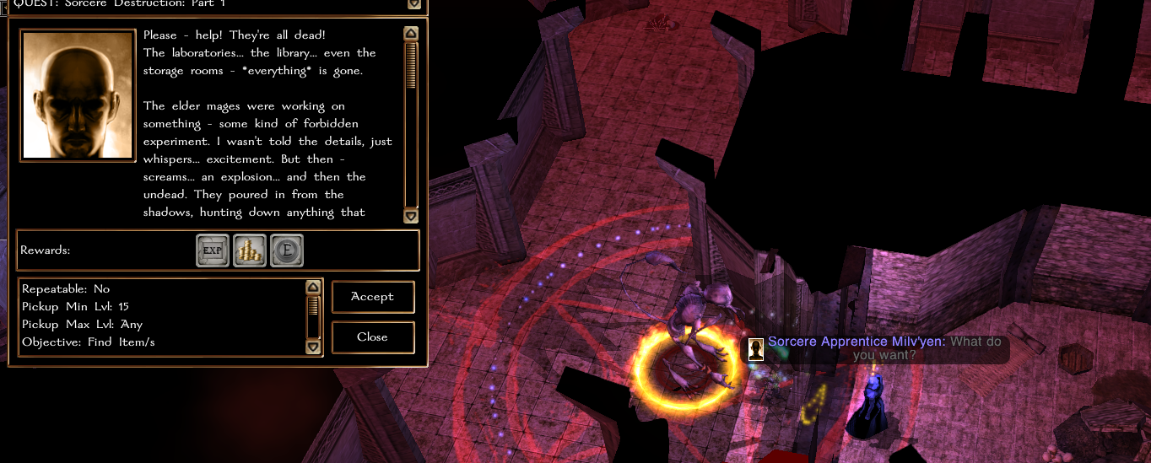

Search Pile of Arcane Books for quest item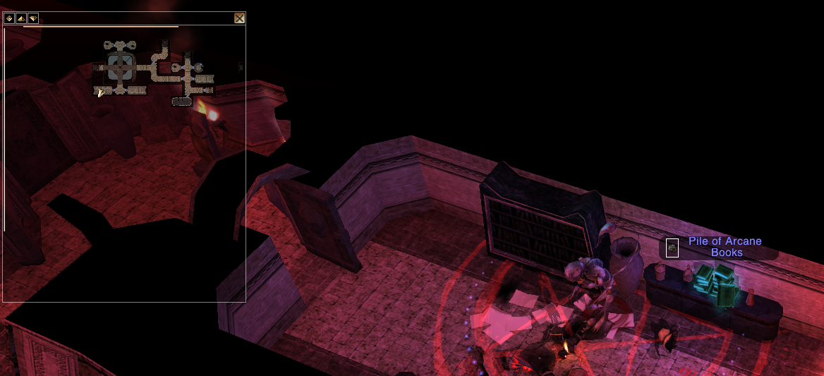
Return to Milv’yen, advance the quest
Kill Awakened Blackavar Enforcer to get Depleted Token of Possession
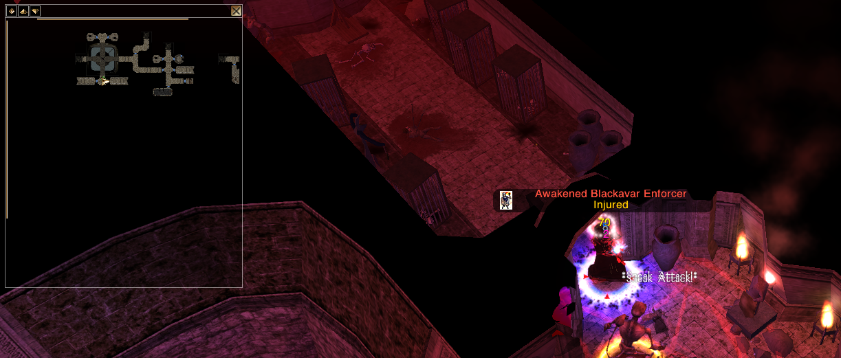
Return to Milv’yen to get Depleted Token of Possession
Enter Temple of Lloth
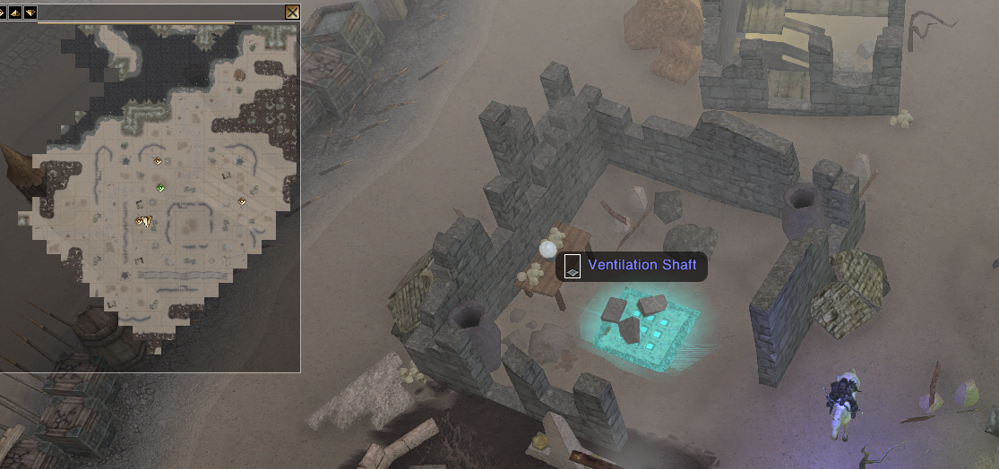

Talk to High Priestess of Lloth to get Cleansed Token of Possession
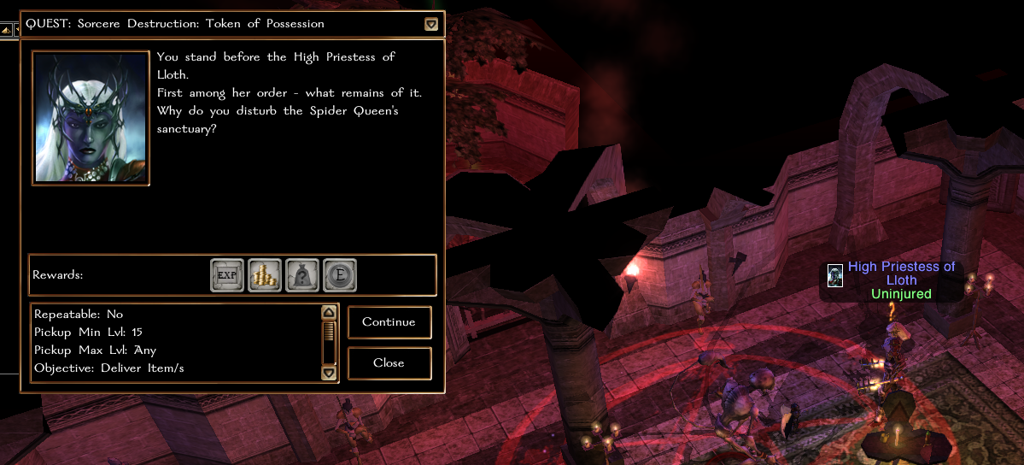

Head back to your respective Dragon.

The Shadow Lair (Living Questline)

Head to Sholo Plains (boat to Brosna -> west 3 maps to Sholo plains) and enter crypt. Alternatively, if you can get to Makanor, you can surface out into the same map.
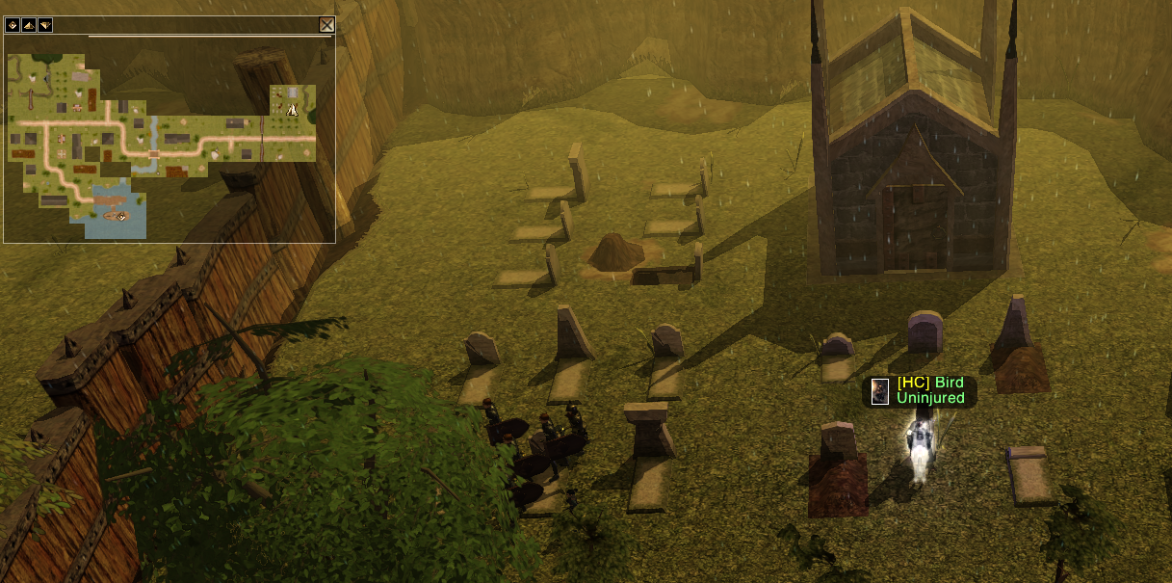
Fight your way down 2 levels to reach Ancient Mythallar and loot the Orb of Arcane Power. Don’t forget the chest to the left for a Celestial Silver Key.
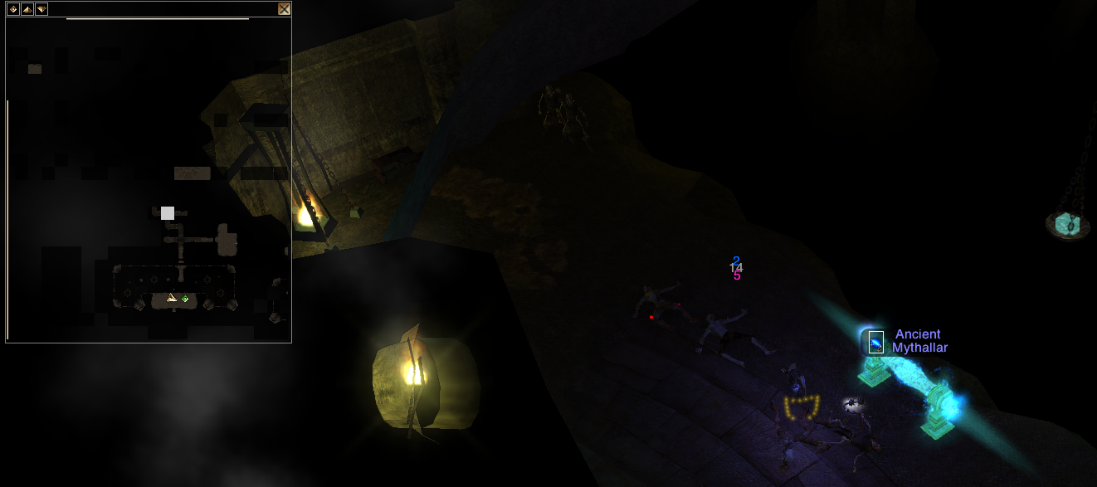
Head back to your Dragon.

